CATALOGING ASSIGNMENT
15 grade points

The recorded interview is complete and processing begins! Now it will continue in its life cycle to be copied, labeled, shelved, and catalogued. Cataloging is one of the most important tools for access, and what we practice in this assignment.

In a real life situation, the interview often changes hands at this point, passing from the creator (interviewer) to the curator (cataloger/archivist). Depending on the repository, sometimes the cataloger is a professional archivist with expertise in cataloging but knows nothing about oral history or the topic of your work; other times it may be a volunteer working for a project or small organization who is an inexperienced cataloger but knows and cares a lot about the project. Sometimes the interviewer does the cataloging. In every case, it can be assumed that the cataloger will not have the time to listen to the interview or to follow up on cataloging questions. It is the oral historian’s responsibility provide information about the interview completely, correctly, and consistently. In this class we do this through the Interview Summary form.

REMEMBER: the oral historian (as creator) is responsible for the content and the cataloger (as curator) is responsible for the cataloging structure.

Overview
In this assignment you will switch roles and become the cataloger for your classmates’ interviews. You will use information recorded by your classmates on Interview Summary forms to create simple cataloging records based on Dublin Core. You will create catalog records for three interviews of your choice. Then you will evaluate the process at several levels and post a sample catalog record along with your evaluation on the cataloging discussion board.

NOTE: This assignment is designed so you can catalog successfully without any previous cataloging experience. Therefore, some steps have been simplified. In particular a) I’ve taken some liberties with the Dublin Core metadata set for this assignment, and b) we will not use controlled vocabulary, even though it is an essential part of cataloging oral histories.

Details
- After you read through these instructions, begin by printing out the Cataloging Template, Data Dictionary, and the examples. Spread the examples out in front of you and notice how the Cataloging Template relates to the Interview Summary form. Make sure you understand the correspondences between the two forms.
- Review the Interview Summary forms of your classmates. Select three that you wish to catalog.
- Review the Data Dictionary for Oral Histories document to understand the correspondence between Interview Summary fields and Cataloging template fields. (see explanation below).
- Download the Cataloging Template and save three copies – one for each catalog record you will create. Name the document with the Narrator’s name.
- Create a catalog record for each interview you have chosen, using information from the Interview Summary form. Use judgment as to what to include, when to paste directly, edit, shorten, or change.
- Describe and evaluate the process, addressing the following and other issues that strike you:
a. Interview Summary forms: What do you notice about individual styles in completing them? Level of detail? How did you select which three to catalog? Was the information clear? If not, how could it be improved?
b. Cataloging template: Describe your thought process in transferring information. How much did you edit the information vs. copy directly? Is the data dictionary clear? Were some interviews more difficult than others to catalog? Why?
c. Cataloging oral histories: Based on this assignment and your readings, what are some of the biggest problems cataloging oral histories? Do forms such as the ones we are using lessen the difficulty? If you are a beginning cataloger, describe the helpfulness of the forms as a tool for cataloging oral histories. If you are an experienced cataloger, how could the workflow be improved?

Submission
This a graded discussion. Turn in two items to the Cataloging discussion forum (as attachments is fine), so classmates can view and discuss:
a. Complete Cataloging Template for one of the three cataloging records you created.
b. A short discussion of our experience including the questions in #5 above

SEE P.3. BELOW FOR GRAPHIC EXPLAINING FIELD CORRESPONDENCE BETWEEN THE TWO FORMS

EXPLANATION OF THE DATA DICTIONARY
Corresponding Dublin Core metadata element. This means fields can be mapped to any number of other cataloging systems
Corresponding fields from Interview Summary form. These field names and descriptions are more suitable for oral historians, while the Dublin Core field definitions are better understood by catalogers and technical people.
Adaption of Dublin Core elements to this project. Using this structure, our catalog records could be mapped to any larger cataloging system
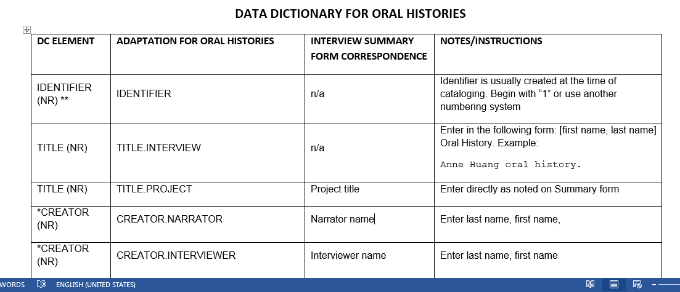

You will notice that the Cataloging Workform Template and the Interview Summary forms record more or less the same information, but designed for different user communities. The Interview Summary form is designed for the interviewer and project team to record information that makes sense to them. The Cataloging Workform Template is designed to organize information in a way that it can easily be retrieved in an computerized catalog of access system.

